AFOUMBA GILLES BERTRAND  General Practitioner  📍 Yaoundé, Cameroon  📞 (+237) 688 99 65 49  ✉️ afoumbagilles7424@yahoo.com | 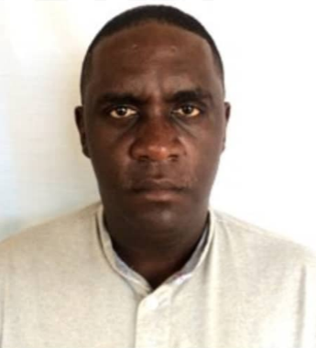
PROFILE
Dedicated and compassionate medical doctor with strong experience in general practice and specialized training in ophthalmology, pediatrics, and emergency care. Skilled in patient diagnostics, medical coordination, and interdisciplinary collaboration. Demonstrates strong adaptability, teamwork, and readiness to work in rural and dynamic environments.
EDUCATION
🎓 Doctorate in Medicine – Faculty of Health Sciences, Niamey, Niger (2018)
🎓 Baccalaureate (Series D) – Collège de la Retraite, Yaoundé (2008)
🎓 BEPC (2005), CEPE (2001)
PROFESSIONAL EXPERIENCE
🟢 General Practitioner – DEO GRACIA Polyclinic (Nov 2021 – Feb 2023)
🟢 General Practitioner – Nkoulou Medical Center (Oct 2020 – Oct 2021)
🟢 Consultant Doctor – Henry Dunant Medical Center, Red Cross Cameroon (Jun 2019 – Aug 2020)
🟢 Ophthalmology Internship – CNHU Cotonou, Benin (Oct 2023 – Jun 2024)
TRAININGS & CONFERENCES
- World Arthritis Day – AJANTA PHARMA
- Malaria Management – NOVARTIS Symposium
- Pediatric Internship – Efoulan Hospital
- Ophthalmology Workshops and Congresses – Cameroon & Niger
- Research in Ocular Echography – IHH & Lamordé Hospital
KEY SKILLS & ATTRIBUTES
- Emergency care & outpatient management
- Team coordination & patient communication
- Word, Excel, PowerPoint, Publisher
- Driving license (Category B)
- Available for rural and dynamic contexts
- Flexible and responsive to urgent medical calls
LANGUAGES
French: Fluent (spoken and written)
English: Intermediate (written), Basic (spoken)
INTERESTS
Military diplomacy, Reading, Travel, Sports

