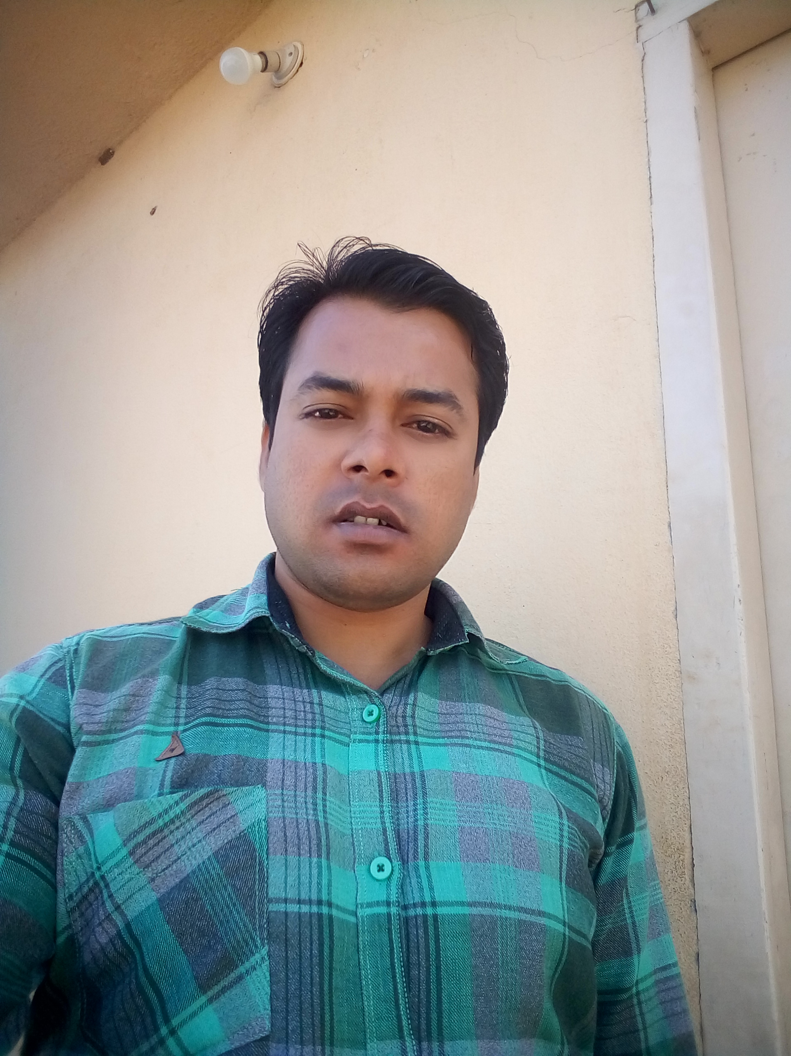

CURRICULUM VITAE

JANJEERA MEHRA
A- Ganesh Talkies, Shamshabad, Hyd, TS
Whatsapp/Call :+91-9617880117
janjeera.official@gmail.com
_________________________________________________________________________________________________________________________________________________________________________________________________________________________________________________________________________________________________________
Career Objective:-
Goal-oriented individual seeking a position as Team Lead with your company in order to apply leadership and management skills to motivate team members and increase productivity.
Academic Qualifications:-
SN | QUALIFICATION/FACULTY | UNIVERSITY/BOARD | MARKS IN % | PASSIGN YRS
1 | N.E.T. | From Rajasthan University | 72% | 2015
2 | M.PHIL | FROM Rajasthan University | 68% | 2014
3 | M.A. IN ECONOMICS | FROM JNU | 65% | 2013
4 | B.A. IN ECONOMICS | FROM Rajasthan University | 50% | 2010
5 | 12th | FROM BSER | 55% | 2007
6 | 10th | FROM BSER | 60% | 2005

Professional Qualifications:-
- Advanced Excel (Vlookup, Pivot Table, Chart, Sumif, Macros etc)
- Tally ERP 9.0
- RS-CIT (MS OFFICE & INTERNET)

Manager and Leader Skills :-
1. Communication - Able to clearly and succinctly explain to your employees everything from organizational goals to specific tasks.
2. Motivation - Build employee self-esteem through recognition and rewards, or by giving employees new responsibilities to increase their investment in the company.
3. Delegating - Identify the skills of each of your employees, and assign duties to each employee based on his or her skill set.
4. Positivity - A positive attitude can go a long way in an office.
5. Trustworthiness - Employees need to be able to feel comfortable coming to their manager or leader with questions and concerns.
6. Creativity - As a leader, you have to make a number of decisions that do not have a clear answer; you therefore need to be able to think outside of the box.
7. Responsibility - A leader is responsible for both the successes and failures of his or her team. Therefore, you need to be willing to accept blame when something does not go correctly.
8. Flexibility - Mishaps and last-minute changes always occur at work. Leaders need to be flexible, accepting whatever changes come their way. Employees will appreciate your ability to accept changes in stride and creatively problem-solve.
9. Commitment - It is important for leaders to follow through with what they agree to do. You should be willing to put in the extra hours to complete an assignment; employees will see this commitment and follow your example.
10. Feedback - Leaders should constantly look for opportunities to deliver useful information to team members about their performance. However, there is a fine line between offering employees advice and assistance, and micromanaging.
11. Management - Team develop, Train and Management, Better Understand about company and products.
12. Productive - Believe in smart work and working productively. Bring the project towards 35% Annually growth.
13. MS Office - Having 10 yrs working in system, fluent in ms office.
14 Advanced Excel - 3 yrs working experience in XL formulas, vlookup, pivot table, countif, sum, substitute etc.

Work Experiences:-
1. Paschim Media Production & Events PVT LTD - 1 Year Working Experience as a TL Cum INCHARGE At Axis Bank Project, #29 Writer Information Management Service Pvt Ltd, Hyderabad 501218
Period _ 1st Jan, 2017 - 31st Dec, 2017
Job Role & Responsibilities:-
- Team Development, Training, Drive and Management.
- MIS preparation Daily, Monthly and Quarterly Basic.
- Monthly Attandance & Salary Slip Preparation.
- Monthly Billing & Invoice Raising.
- Handling the project independent.
- Identified and resolved all needed grievances.
- Performed all other tasks as assigned.

2. ACN DIGITAL PVT LTD – 1 Year Working Experience as Asst Manager MIS at 509,Shagun Sqaure, Vijay Nagar, Indore MP.
Period _ 1st Jan, 2016 - 31st Dec, 2016
Job Role & Responsibilities:-
- Invstory & Management with 25 Station
- Cables Management(D.C. Line, Lease Line and Operator Wise)
- Inward/Outward Material (STB, REMOTE, NET CABLE, FEED)
- Receiving Billing / Commission Amt from all 25 stations.
- Payroll Salary & Pay slip Preparing for all 25 station's employees
- Daily expenses and advanced pay Report preparation.
- DCR report maintaining daily.

3. ONDOOR CONCEPT P LTD – 1 Year Working Experience as STORE INCHARGE MIS at 163, MP NAGAR ZONE-II, BHOPAL MP.
Period _ 1 Jan, 2015 - 31 Dec,2015
Job Role & Responsibilities:-
- Mandi Purchase Inward (Fruits & vegetables).
- Grocery Purchase Inward (All type grocery items.Beverages, Cosmetics, TNT,Toiletries etc.)
- Outward Dispatched to market (Grocery & Mandi items).
- Purchase Grading A to B (Purchase Mandi Items).
- Ageed Grading A to B (Rack previous day Items )
- B- Ware House Selling & Maintaining software & excel sheet.
- Mandi Rate Analysis with previous as maintaining in excel.
- Preparation Mandi Purchase Order and Grocery Purchase Order
- Getting Passed Out To Inwarded Bills Mandi's and Grocery's

4. CMS COMPUTERS P LTD –7 Years working experience as CASHIER at GANESH NAGAR-A, SODALA, JAIPUR RAJ.
Period _ 1st Jan 2008 - 31st Dec 2014
Job Role & Responsibilities:-
- Cashier profile as Cash Handling and Billing Operator.
- Data receiving and maintaining by software from portal daily.
- Data dispatch to govt. offices daily.
- Data maintaining by software and excel day by day.
- Data sent to server room for data updation.
- MIS Preparation & Data Reports Maintaining.
- Issue receipts, and update records for cancellation of orders and refunds.
- Identified and resolved all needed grievances.
- Performed all other tasks as assigned.

PERSONAL DETAILS:-
Name : Janjeera Mehra
Father’s Name : Bharat Mehra
Date Of Birth : 03-01-1988
Marital Status : Un-Married
Language Known : Hindi & English.
Sports & Hobbies : Playing cricket & Reading books, listening music.

Declaration : I hereby declare that the information furnished above is true to the best of my knowledge.

References : Available on request
Date : 24/ 03/ 2018 Signature
Location : Hyderabad, TS. Janjeera Mehra

