NAME:
ATIQA

EDUCATION:
- Currently enrolled in BS English language and literature (2016-2020), International Islamic University Islamabad.
- F.sc (pre-medical), Public School and colleges Jutial Gilgit, passed with A-1 grade.
- Metric (Sciences), Public School and colleges Jutial Gilgit passed with A-1 grade.
OTHER SKILLS:
- I have good writing skills.
- Command over MS Office.
- I have good communication and presentation skills.

LEISURE SKILLS:
- Internet surfing
- Singing
- Story Writing
- poetry
WORKS:
Some of my work is given below
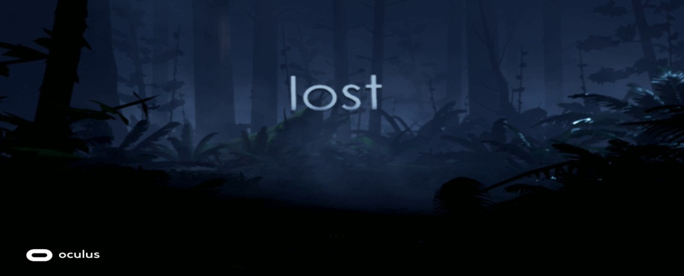

Alone in a dark corner…….
With tears pouring down my face.
I was waiting for you…….
To come and wipe them away.
I was scared, depressed and angry.
I was losing everything.
But one thing I didn’t wanted to lose was YOU……..
I waited and waited!!!!!!
I called you again and again!!!!!
Until I couldn’t call you any longer.
Because I was choking up on my tears.
But you never answered.
My tears dried up.
My heart toughened.
The pain faded.
My dreams got ruined.
Marking it the moment……..
When I lost everything.
I hated you for not answering me.
I hated you for abandoning me.
But why is that I can’t hate you anymore!!!!
Why do I miss our lost connection?
So sometimes…….
I wonder!
If I could go back in time……
Back In that dark corner of the room again……
Will I trust you once more?
Will I call your name again?
But the biggest question is,
Will you come this time?

