Faizan Ali
House No. 21, Kalyal B/5, Mirpur A.K.(Ready to relocate)
Contact: +923435270616
Email: alifaizy007@gmail.com

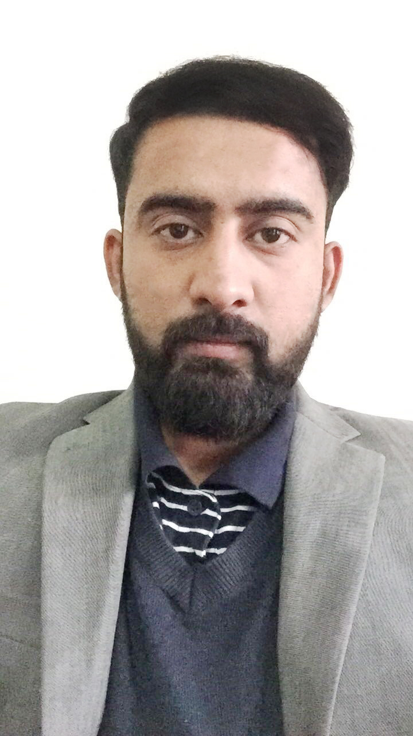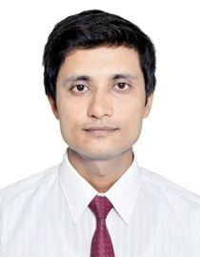

CAREER OBJECTIVE:
Achieve the Targets with hard working, Positive respond to changes with my practical work experience. Gradually reach the supervisor level position in Professional Hierarchy of Organization.

CORE STRENGTHS AND ENABLING SKILLS:
MS Word Fast Typing Speed Adobe Illustrator
Adobe Photoshop WordPress Bootstrap

PROFESSIONAL WORK EXPERIENCE:
Organization: Local Market
Tenure: August 2016
Designations: Web Developer (WordPress)
Responsibilities:

- Analyzing the demands and requirements of customers.
- Collecting out the functionality of complex websites from customer.
- Designing the layouts of website.
- Designing the Slider Images and Banners for website.
- Communicate with the customer and getting feedback regarding work.
- Delivering the final work to customer.

Organization: Fiverr (online marketplace)
Tenure: March 2014 – November 2016
Designations: Graphic Designer
Responsibilities:
- Finding out the customers from the market.
- Managing orders with FIFO strategy.
- Deal with the customer and analyzing the requirements of the customer.
- Offering the best Packages to the customers as compared to the Market.
- Designing the Logo Designs.
- Designing the Flyers, Brushers and Labels.
- Designing Business cards, Letterhead and Email Signature.
- Displaying and updating the work on Portfolio.
Organization: Azad Mega Mart (Shopping Mall)
Tenure: January 2012 – October 2013
Designations: Till Cashier
Responsibilities:

- Associate the Supervisor to manage the accounts.
- Follow the instructions of Manager regarding new procedures and IT Changes.
- Update the list of new arrivals in every section.
- Update the prices of new arrivals.
- Merchandising the Items, inform to department supervisor regarding the expiry of the Items.
- Pay off the cash to the Head cashier.
- Managing Bills and Cash.

ACADEMIC EDUCATION:
Degree Program EXAMINING BODY: YEAR
- BS(IT) Mirpur university of Science & Technology 2017

- F.S.C Pak Kashmir Institute of Computer Sciences 2012

- Matriculation Pak Kashmir Institute of Computer Sciences 2010

PORTFOLIO:
Website URL: “http://www.fastcreditoptions.com/”
Description: A credit card repair company website.
Platform: WordPress
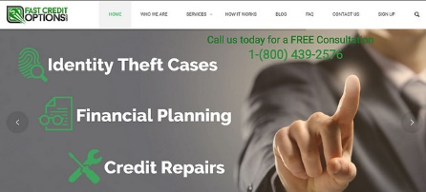

Website URL: “http://www.smartappsoffice.com/”
Description: A mobile apps development business.
Platform: WordPress
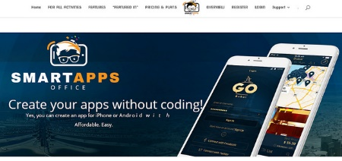
Website URL: “ http://www.instantcarsolution.com.my/”
Description: A rent a car company.
Platform: WordPress
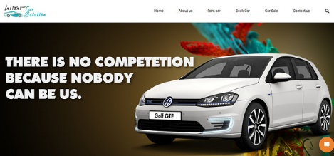

Online Portfolio: https://www.flickr.com/gp/154095405@N08/oUzj35

INTERESTS AND HOBBIES:
Badminton and creative activities.

PERSONAL INFORMATION:
Father’s Name: Iftikhar Ahmed
Date of Birth: 11th September 1994
Religion: Islam

