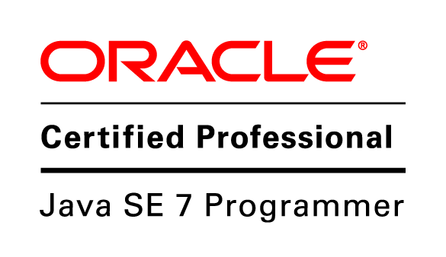
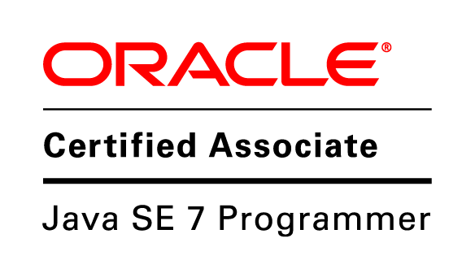
Deepak Kumar
Mob: +91-9004026789
Email: deepk2u@gmail.com

SUMMARY
- More than 4 years experience with extensive skills in Programming and Infrastructure management. These skills are coupled with hands on experience, and demonstrated strategic, technical and thought leadership, leading to innovative developments.
- Worked as Solution Integrator in Ericsson India Global Services Pvt. Ltd from October 2011 till September 2013
- Worked as Software Developer at PayTM from September 2013 till December 2013
- Worked as PLM Consultant in Technia from December 2013 till July 2015
- Working as Senior Software Engineer / Team Lead at V Group since July 2015

JOB OBJECTIVE
To work in a Technical Role in an Organization operating in the field of Information Technology. Looking for a role that allows me to implement my skills for the success of the project assigned to me. Also looking to bring in the knowledge and experience gained while working on project using Programming, Cloud technology and Research.

TECHNOLOGY EXPERTISE

- Good Understanding of Computer Science Basics
- Expert programming skills in Java, C, Node.js, Javascript
- Expertise in the field of data analytics using Hadoop and related technologies
- Experience in setting up Apache Solr for indexing
- Experience of working with AWS web services like EC2, Elastic beanstalk, S3, RDS, Elastic cache
- Expertise in setting up and managing Hadoop Clusters
- Experience in plug-in development for Mozilla Thunderbird and Firefox.
- Experience in Business process designing using BPMN 2.0 standard.
- Delivering lectures on BPMN, Process designing and deployment
- Experience in development and deployment of applications based on J2EE.
- Worked extensively in object-oriented technology using Java, GWT, spring, JPA, JavaScript, RestyGWT, SOAP and REST Web services, Hibernate, Redis IO and XML.
- Good experience in AGILE methodologies.
- Having Designing skills using Html5 and CSS.
- Good knowledge of PLM domain specially in Apparel Industry
- Expert in Enovia, a Dassault Systemes product for PLM
- Expert in TVC, a Technia product for PLM
- Oracle certified JAVA professional for Java 7 (cleared both exams 1ZO-804 and 1ZO-803)

CURRENT JOB DUTIES
- Determining operational feasibility by evaluating analysis, problem definition, requirements, solution development, and proposed solutions.
- Documenting and demonstrating solutions by developing documentation, flowcharts, layouts, diagrams, charts, code comments and clear code.
- Preparing and installing solutions by determining and designing system specifications, standards, and programming.
- Improving operations by conducting systems analysis; recommending changes in policies and procedures.
- Obtaining and licensing software by obtaining required information from vendors; recommending purchases, testing and approving products.
- Managing team and distributing work amongst team members

PROFESSIONAL EDUCATION & TRAINING:

- B.Tech in Information Technology (2011) from College of Engineering Roorkee, affiliated to Uttarakhand Technical University, Dehradun, India. Secured 75% marks.

ACHIEVEMENTS:
- Designed solution to support SOC (Service Operations Center) which is an aggregation of NOC (Network Operations Center)
- Designed business processes to automate many business process in Ericsson like Asset Management Process and Visa Delivery System
- Designed and developed many solutions to support Go- Open architecture in Ericsson
- Contributed to Open source community
- ACE Award winner in Ericsson India.

PROJECTS/ASSIGNMENTS DETAILS:

Designation: Senior Software Engineer / Team Lead
Company: V Group
Clients: V Group
Domain: REST web Services, Desktop Application, IT infrastructure management
- Leading product development team in India
- Responsible for Product designing, development and release management
- IT infrastructure development and management
Environment &Tools: JAVA, MySQL, Maven, Apache Tomcat, REST, AWS, Node.js, Angular.js, Apache Solr

Designation: PLM Consultant
Company: Technia
Clients: Fashion Continent, Fjallraven, Asics, Monoprix, GUCCI, JULA
Domain: PLM

Brief: As a key member of the apparel team, I was solely responsible for providing IT solutions to the apparel industry in Nordics. My job included analyzing the requirements, expected features and functionality, sprint planning and estimation. I held the sole ownership of the project taking care of development, testing, deployment, customer interaction, testing environment, and production deployments
Environment &Tools: Enovia, TVC, JAVA, Ajax, JSP & servlets, Oracle, MS SQL, Ant, Gradle, Apache Tomcat

Designation: Solution Integrator (Worked as Subject Matter Expert-Hadoop)
Company: Ericsson India
Client: Ericsson India
Domain: Data Analytics, Network Operations, Programming, Cloud Computing

Project: SOC
Brief: SOC provides an integrated view of network operations, which is part of Ericsson service portfolio. Main idea is design a solution that will monitor services instead of network nodes.
Location: Noida, India
Role: SME-Hadoop and Data analytics
Date-January 2013 – September 2013

Responsibilities/Tasks:

- Working closely with NOC and service delivery team to gather requirement and identify issues and finding solutions.
- Evaluating different solutions available in Hadoop stack, doing POCs and bringing it into solution stack
- Working closely with development unit to develop solution
- Taking care of all Analytics Decisions & Implementation including programming
- Setup of Hadoop clusters to develop, test and solution deployment
- Installation of Openstack cloud framework for Hadoop cluster setup
- Writing MapReduce programs to analyze log data from different network nodes.
- Driving Hadoop competency development inside team

Designation: Solution Integrator
Company: Ericsson India
Client: Internal
Domain: Cloud Computing, Web Technology
Location: Noida, India
Project: MyCloud
Brief: This is a web portal based on OpenStack Horizon. It includes mirroring of OpenStack cloud computing service to inject own services other than provided by OpenStack, to the end users.
Location: Noida, India
Role: Programmer
Date-January 2013 – June 2013

Responsibilities/Tasks:
- Study the architecture of Openstack Cloud platform
- Develop interface between web application and openstack using Node.js
- Client side development using Backbone.js, HTML5, CSS and JavaScript
Designation: Solution Integrator
Company: Ericsson India
Client: Internal
Domain: Process Automation, Web Technology
Location: Noida, India
Project: System X
Brief: System X is an initiative by the CTO of Ericsson to make smarter systems, which are ahead of the market. It involves the designing and development of a platform, which can be used by Ericsson to automate its existing business processes.
Location: Noida, India
Role: Programmer and SME- BPMN and Business Process designing
Date-June 2012 - present

Responsibilities/Tasks:
- Doing POCs to evaluate different available BPMN solutions and also different web technologies
- Business process designing and deployment using Bonitasoft Business process management suite
- Programming for server side as well as client side
- Database designing
- Following Agile methodology for development
- Taking care of production, test and Development environment
- Hudson Continuous Integration tool installations and configuration
- Installing and configuring GITHUB server for code repository, project wiki and bug tracking
- Designing user interface in GWT, HTML5, CSS, Twitter Bootstrap

Designation: Solution Integrator
Company: Ericsson India
Client: Internal
Domain: Solution Engineering
Location: Noida, India
Date-November 2011 – June 2012

Project: Go Open
Brief: GO-OPEN is an initiative taken by Ericsson Management for transition of all its existing Global IT application to Open-Source Platform. As Ericsson formed a new entity Ericsson Global India Services with a message being an ICT company, their main focus was to create their own IT infrastructure to build Competence in this domain for future expansion.

Responsibilities/Tasks:
- Designing and programming solutions
- Created multiple plugin for Thunderbird to make it work like Outlook
- Created PDF converter solution to convert Microsoft office document and presentations to PDF
- Customization and configuration of OTRS, an open source ticketing system
- Customizations and configuration of Nagios, an open source monitoring system
- Make technical recommendations to management.
- Understand business unit’s problems, need, or opportunity and to design an IT solution that appropriately addresses the business problem, need, or opportunity.
- Communication and collaboration with open source groups for finding solutions
- Went to Sweden to work with an open source programmer for developing Microsoft Exchange Calendar plugin for Mozilla Thunderbird

RESEARCH AND DEVELOPMENT DURING COLLEGE
Internship with IBM
Information Security Maturity Model based on ISO 27001:2005 (under the guidance of Mr. Neeraj Gupta, General Manager, IBM India Pvt. Ltd. & Mr. Ankush Mittal, Dean, College of Engineering, Roorkee)

Responsibilities/Tasks:
- In depth study standards available for information security like ISO 27001:2005
- Designing an extensive information security solution which gave an insight of Information security inside the organization
- Develop application software with a questionnaire to find the maturity level of any organization
- Included benchmarking to provide the stats and status
PERSONAL INFORMATION:
Date of Birth: 29th Aug 1989
Nationality: Indian
Marital Status: Married
Passport No: K1115314
Language Known: English, Hindi
Hobbies / Interest: Reading, Writing blogs, Listening Music and Cooking

Pune Deepak Kumar

