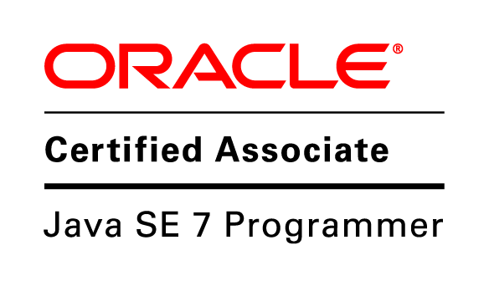
APARNA SINGHAL
Mobile: +91 9987276789
aparna311989@gmail.com

SUMMARY

- Worked as Software Engineer in One97 communications Pvt. Ltd. for 2 years
- Worked as PLM Consultant in Technia for 1.5 years
- Working as Senior Software Engineer in Vgroup Consultancy since September 2015.
- Successfully managed various web projects with small, medium, and multinational corporations in different fields like “Telecom”, “agriculture” which added more than 10,00,000 INR of revenue to the company and attracted new clients.
- Remarkably decreased time for data analysis and improved data quality by developing a data processing tool using Hadoop

CURRENT JOB DUTIES

- Reviewing current systems
- Presenting ideas for system improvements, including cost proposals
- Working closely with analysts, designers and staff
- Producing detailed specifications and writing the program codes
- Testing the product in controlled, real situations before going live
- Preparation of training manuals for users
- Maintaining the systems once they are up and running

TECHNOLOGY EXPERTISE

- Good Understanding of Computer Science Basics
- Expert programming skills in Java, C, JavaScript
- Worked extensively in object-oriented technology using Java, spring, JPA, JavaScript, SOAP and REST Web services, Hibernate and XML.
- Experience in development and deployment of applications based on J2EE.
- Expertise in setting up Apache Solr for indexing
- Experience in development and deployment of desktop application using node.js and PHP.

- Expertise in the field of data analytics using Hadoop and related technologies
- Good experience in AGILE methodologies.
- Having Designing skills using Html and CSS.
- Good knowledge of PLM domain specially in Consumer and Life sciences domain
- Having knowledge of Enovia, a Dassault Systems product for PLM
- Having knowledge of TVC, a Technia product for PLM

SKILLS

J2EE/Web Technologies Servlet, JSP, JDBC, Ajax, Html, JavaScript, CSS, PHP,
Solr, Angular js, Android, REST web services, node js
Languages Known C, Java
Databases MYSQL, Oracle
Tools/Software/IDE Turbo C++, Eclipse, Android Studio
Application server Tomcat
Application software MS office, MS word, MS power point.
Operating Systems Windows, Linux
PLM Specialization Enovia, TVC
Others Hadoop

PROFESSIONAL EXPERIENCE

Vgroup Consultancy September 2015 – Present
SeNIOR SOFWATE ENGINEER
- Responsible for Product designing, development and release management
- Estimation, design and development of various modules.
- Bug fixing and maintenance of the product.
- Managed back end of product using REST web services.
- Android application development.
- Development of desktop application using NODE JS and PHP.

Technia
PLM Consultant February 2014 – September 2015
APPLICATION DEVELOPER
- Providing consultancy to customers for implementing and maintaining their PLM application
- Development of PLM application using java, xml, JavaScript, Enovia and TVC
- Product development related to business area specially for consumer and life sciences industry
- Visiting customer sites for product training, requirement gathering

One 97 Communication Pvt. Ltd. September 2011 – February 2014
Software Engineer
Web developer and Designer

- Designed multiple websites using Java, Spring, Hibernate, Struts for many telecom customers like Airtel, Idea, Vodafone and various others
- Developed JavaScript, HTML and CSS for web applications.
- Managed multiple accounts, met clients, prepared proposals, quotations, and gathered requirements.
- Designed database for most of the applications

BIG data analyst
- Processing billions of records from government to check the numbers which are in do not disturb list
- Evaluating different solutions available in Hadoop stack, doing POCs and bringing it into solution stack
- Working closely with development unit to develop solution

EDUCATION

Tula’s Institute, Dehradun, India 2007 - 2011
Bachelor of technology, Major: information technology

PERSONAL INFORMATION
Date of Birth: 31st Jul 1989
Nationality: Indian
Marital Status: Married
Passport No: L4377288
Language Known: English, Hindi
Hobbies / Interest: Reading, Listening Music

Mumbai APARNA SINGHAL

