Abhishek Aggarwal

Experience:

SEO consultant, working with clients all around the world to help them increase their online visibility. I use proven SEO techniques to boost organic traffic from search engines in order to help clients reach thousands of potential new customers.
Bolstering Your Brand with Creative Technical Expertise – That is my Forte

Digital Marketer – SEO, Campaign Management, PPC Expert, Social Media Management, SEO/ SEM.

RankingBySEO - Search Engine Optimisation Specialist June 2019 – Present
Rocket Fish Digital Marketing Agency (UK) – Project Manager and Digital Marketing Consultant – June 2017 – April 2019

• Develop optimization strategies that increase the company's search engine results rankings
• Creating & identifying the content scope/strategy for the real-time trends & searches
• Identifying trends and suggesting powerful keywords to drive the traffic
• Compiling and presenting SEO guidelines
• Continuously optimizing the content written by the content team
• Analyzing keywords and SEO techniques used by competitors
• Monitor daily performance metrics to understand SEO strategy performance
• Efficiently communicate with the content team and product team to align goals
• Collaborate with others within the marketing department to manage SEO strategy
• Write compelling and high-quality website content, including page descriptions
• Update content and website links for maximum optimization and search engine rankings
• Continuously updating the website based on SEO, search engine, and internet marketing industry trends and developments

Education Details:

Bachelor of Technology, UP TECHNICAL University, UP (2001-2005).

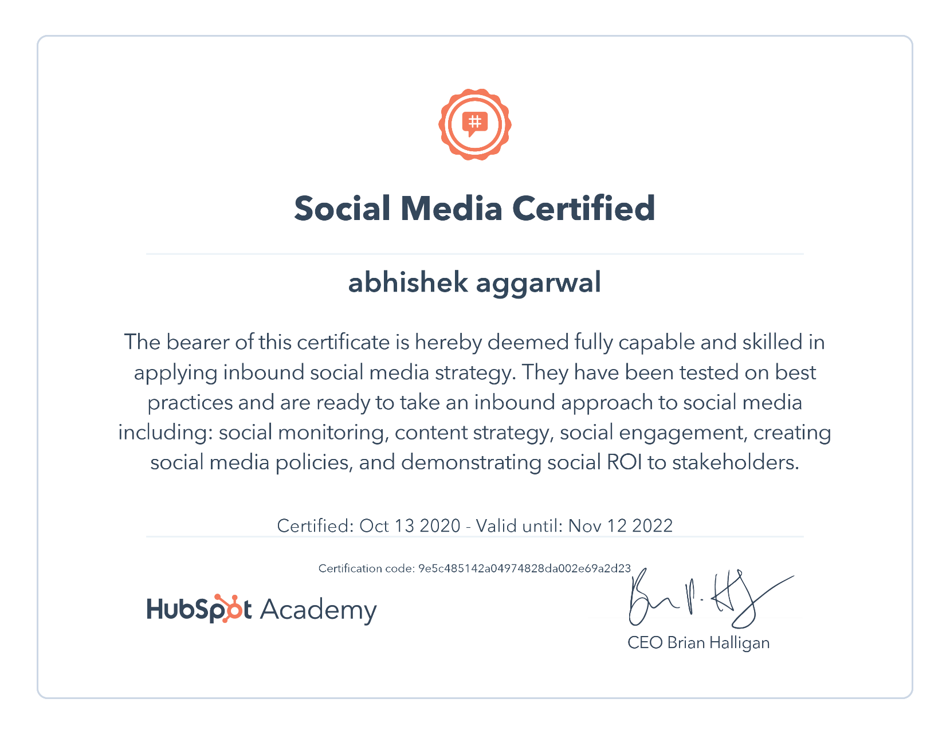
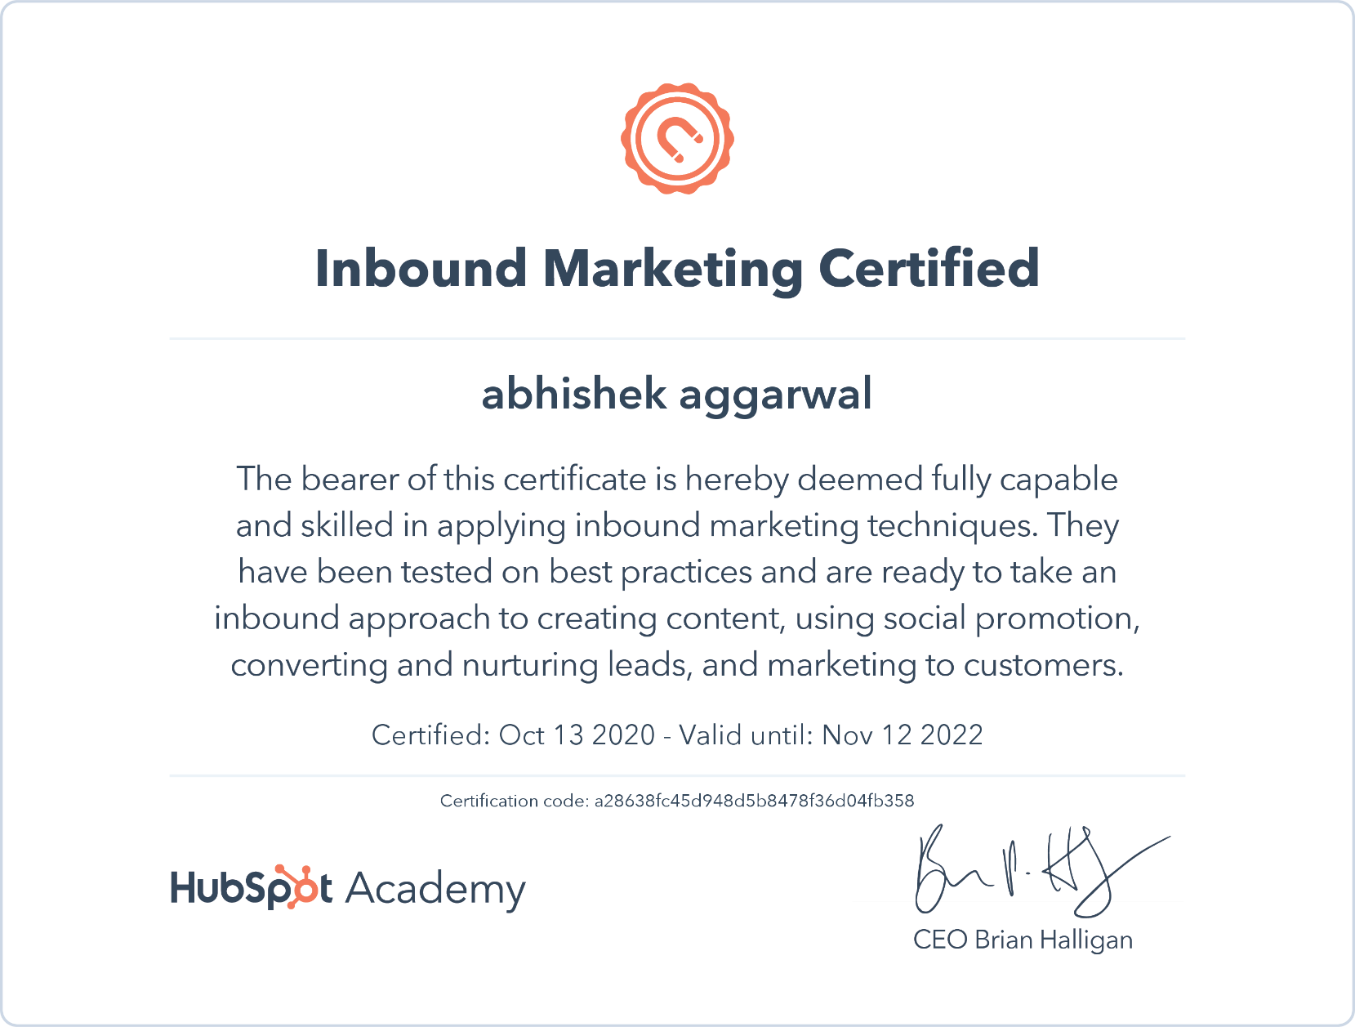

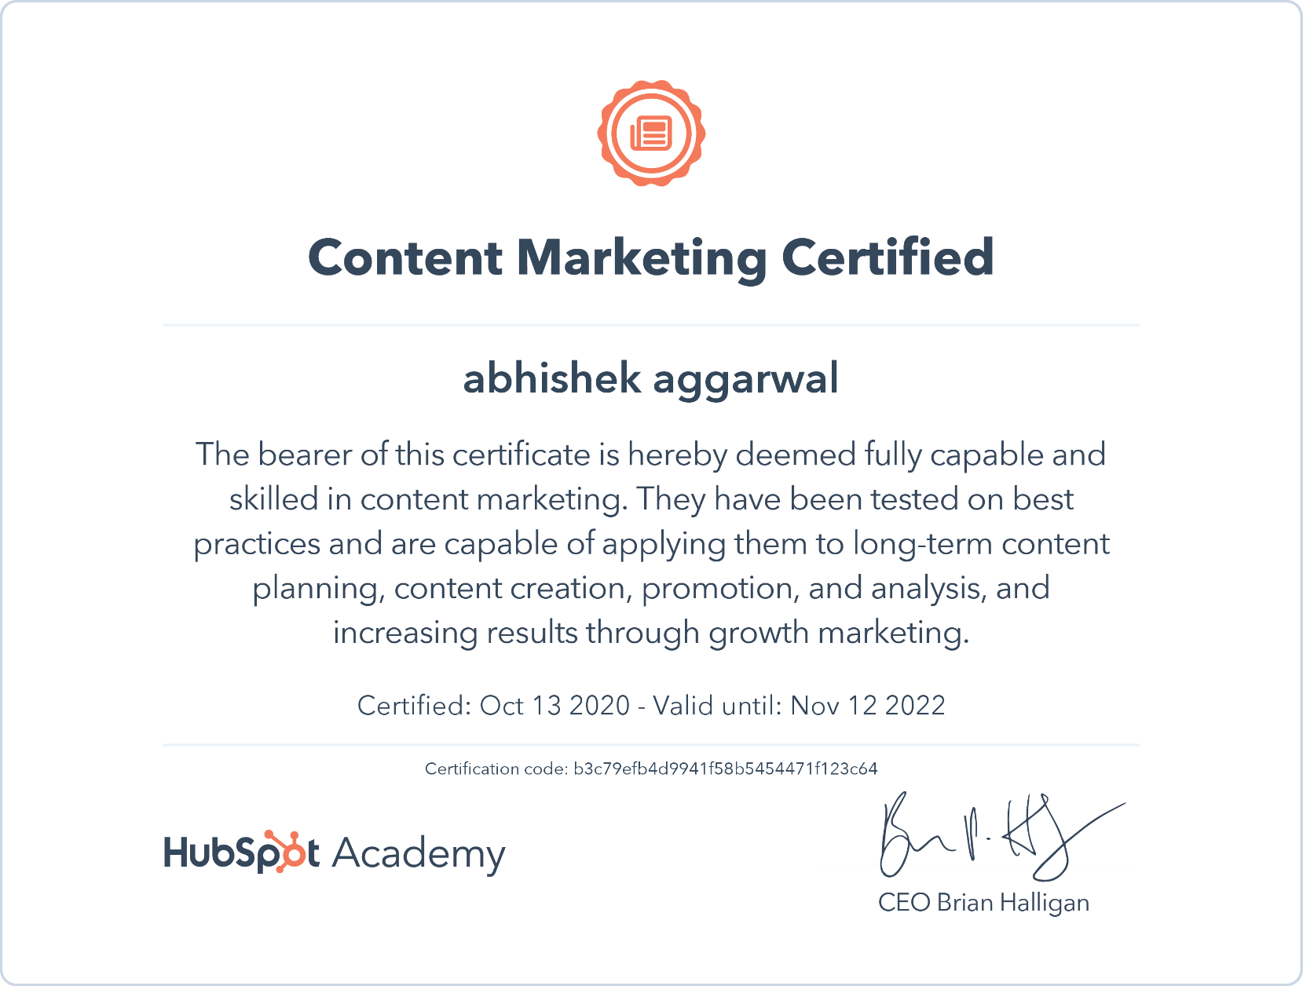

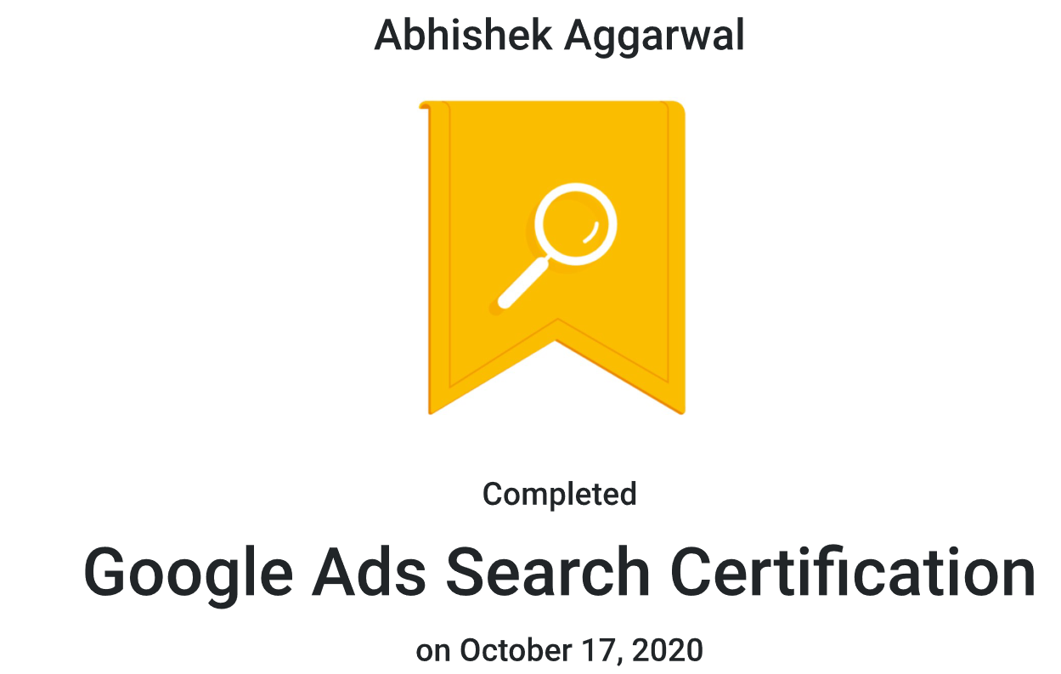
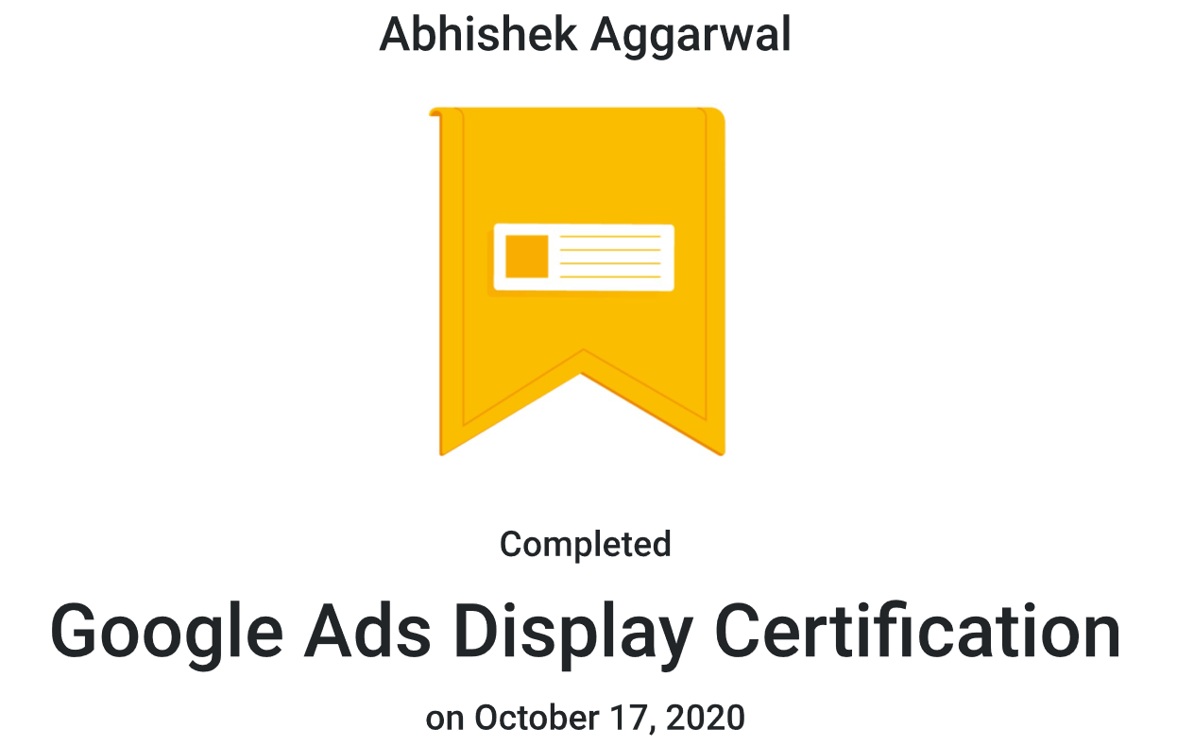

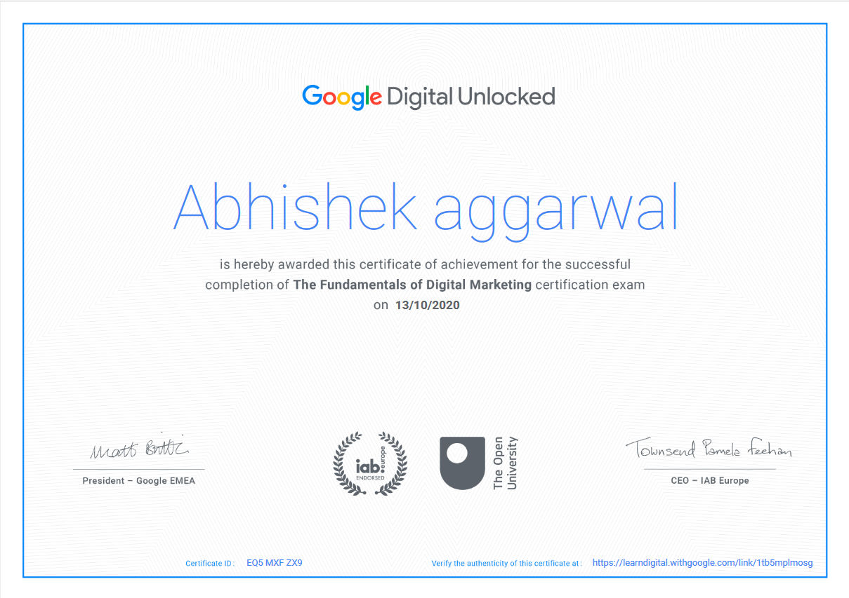

Date : 26/05/2021(Last Update)
Place : Ghaziabad
(Abhishek Aggarwal.)

